**ML System Design for Event Recommendation System**

Video: <https://www.youtube.com/watch?v=ULHk2WYM86M&list=PL_b_MRp1BnEj4UuHv1jAGeO1a0VTRXsAk&index=12>

**Problem Statement:**

To build a personalized event recommendation system for an Event Management and Ticketing platform to increase ticket sales.

**Clarifying Requirements**

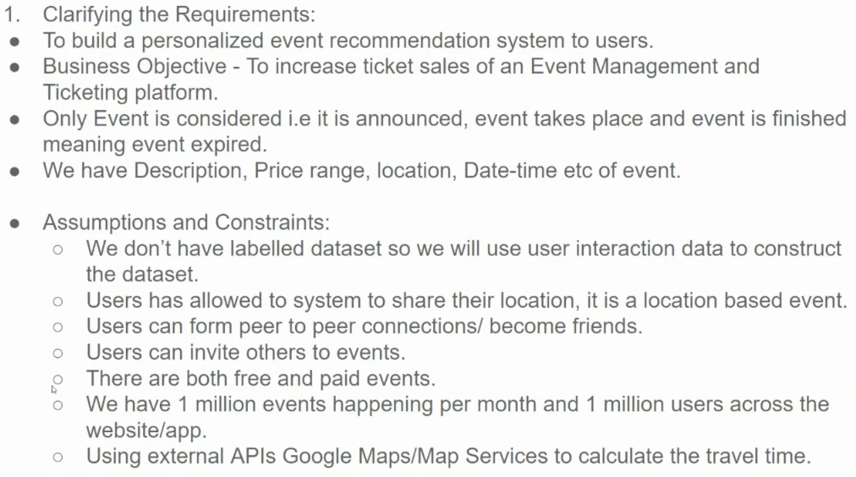

**Key Considerations and Constraints:**

1. **Event Lifecycle:**
   * Events have three states: announced, ongoing, and finished.
   * Recommendations should only be made for upcoming events.
2. **Event Data:**
   * Each event has attributes like description, price range, location, and date-time.
3. **User Data:**
   * Users provide location information.
   * Users can form social connections with other users.
   * Users can invite friends to events.
4. **System Scale:**
   * The system handles a large number of events and users.
     1. The system needs to provide recommendations probably real-time or the event recommendations can be calculated daily as a batch job.
   * External APIs (Google or something else) are used to calculate travel times.
5. What kind of interactions can a user do?
   * Private events: ticket purchase
   * Public events: RSVP – interested, going, not going, not interested

**Potential Recommendation Strategies:**

Given the constraints and data available, here are some potential strategies for building a personalized event recommendation system:

1. **Content-Based Filtering:**
   * Recommend events similar to ones the user has previously attended or shown interest in.
   * Use attributes like event category, genre, location, and price range to find similar events.
   * Challenge: what if this is a new user? Perhaps can recommend events that users friend in same location like/share.
2. **Collaborative Filtering:**
   * Recommend events that similar users have attended and liked.
   * Utilize user-item ratings or implicit feedback (e.g., event attendance, ticket purchases) to find similar users and their preferences.
3. **Hybrid Approach:**
   * Combine content-based and collaborative filtering to leverage the strengths of both approaches.
   * This can involve creating a hybrid model that considers both user preferences and item similarities.

**Additional Considerations:**

* **Real-time Recommendations:** Consider using techniques like real-time indexing and retrieval to provide timely recommendations, especially for time-sensitive events.
* **Cold-Start Problem:** For new users or new events, leverage content-based filtering or knowledge-based recommendations.
* **User Preferences:** Incorporate user preferences, such as genre, price range, and location, to personalize recommendations.
* **Social Influence:** Leverage user social connections to recommend events that friends have attended or recommended.
* **Evaluation Metrics:** Use appropriate metrics to evaluate the performance of the recommendation system, such as precision, recall, F1-score, and user engagement metrics.

**Framing as ML Task**

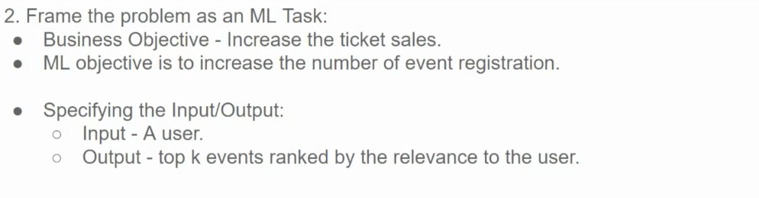

ML problem is to suggest events for the user that the user is most likely to attend. So, a candidate generation (using a recsys algorithm) followed by ranking.

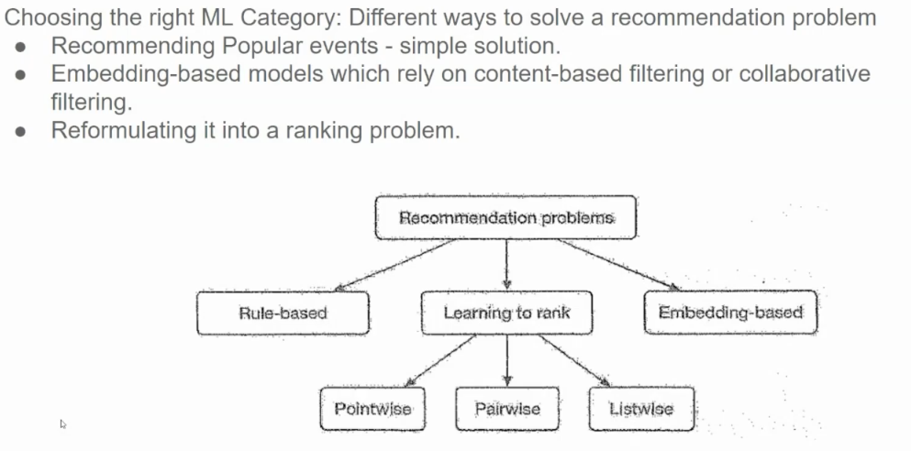

**Recommendation Problems**

1. **Rule-Based:**
   * Relies on predefined rules to make recommendations.
   * Simple to implement but often lacks personalization.
   * Example: Recommending products based on a user's purchase history.
2. **Learning to Rank:**
   * Trains a model to directly to rank items based on their relevance to a user's query or context.
   * Can handle complex ranking scenarios and incorporate various features.
   * Subdivided into three main approaches:
     + **Pointwise:** Treats each item independently and assigns a score.
     + **Pairwise:** Compares pairs of items and learns to rank them relative to each other.
     + **Listwise:** Considers the entire list of items and optimizes the ranking of the entire list.
3. **Embedding-Based:**
   * Represents items and users as dense vectors in a latent space.
   * Similarity between embeddings is used to make recommendations.
   * Can be based on content-based filtering (recommending similar items) or collaborative filtering (recommending items liked by similar users).

**Choosing the Right Approach:**

The choice of approach depends on various factors, including:

* **Data Availability:** The amount and quality of available data.
* **Computational Resources:** The complexity of the model and the scale of the dataset.
* **Desired Level of Personalization:** The extent to which recommendations should be tailored to individual users.
* **Real-time Requirements:** The need for real-time or near-real-time recommendations.

**In the context of event recommendations, a hybrid approach combining multiple techniques might be effective:**

* **Rule-based:** For simple, initial recommendations based on basic criteria (e.g., location, genre).
* **Embedding-based:** For personalized recommendations based on user preferences and item similarities.
* **Learning to rank:** To optimize the ranking of recommended events based on various factors.

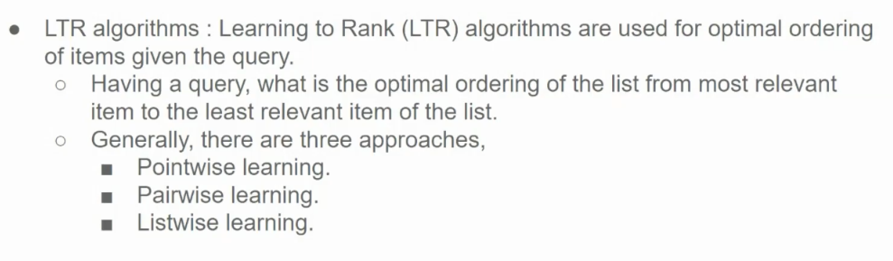

Learning to Rank (LTR) algorithms are machine learning models designed to automatically rank items, making them especially useful in search engines and recommendation systems. They learn the relevance of items based on training data and optimize the order of results to improve user satisfaction.

**Types of Learning to Rank Approaches**

1. **Pointwise**: Treats ranking as a regression or classification problem by assigning a score or class to each item individually. Example: *Linear Regression* or *Support Vector Machines*.
2. **Pairwise**: Considers pairs of items and learns their relative ranking by minimizing the number of incorrectly ordered pairs. Example: *RankNet*, *LambdaRank*.
3. **Listwise**: Directly optimizes the order of a list of items as a whole, typically with a loss function based on ranking metrics like NDCG. Example: *LambdaMART*, *ListNet*.

Each type has trade-offs in terms of computational complexity, accuracy, and applicability depending on the task.

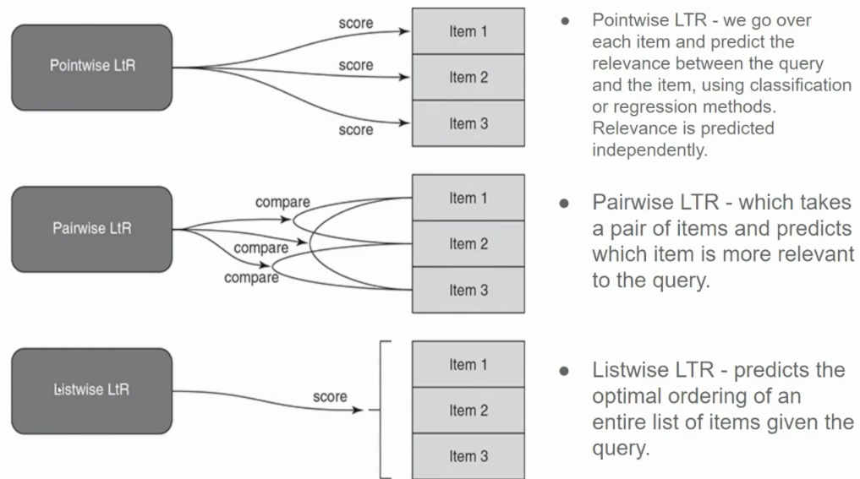

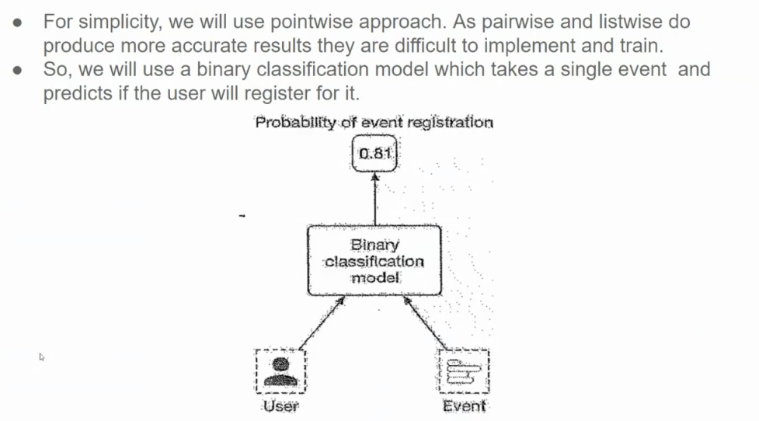

**Data**

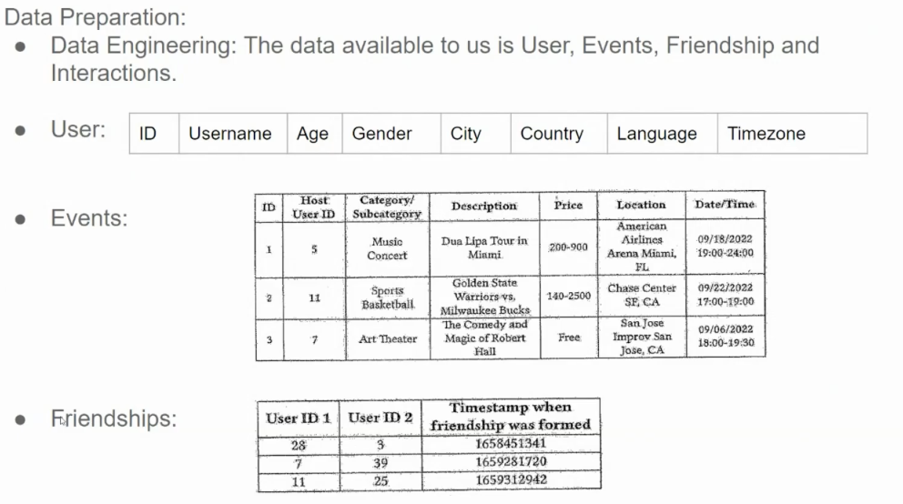

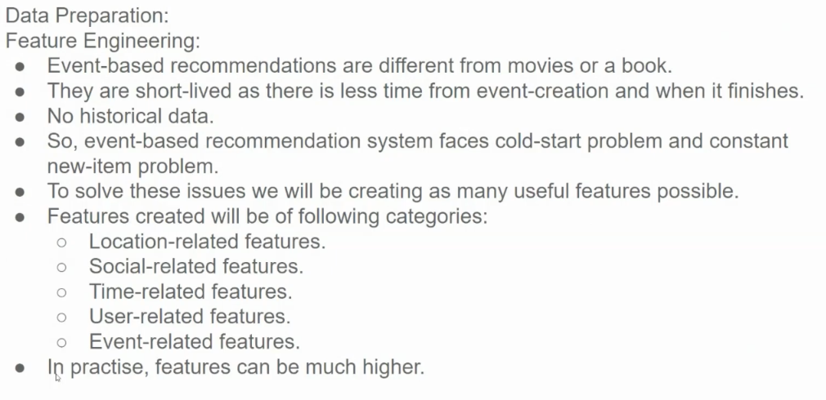

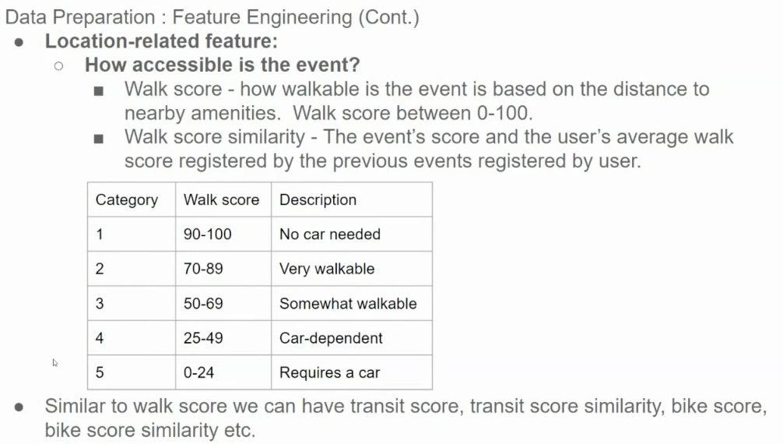

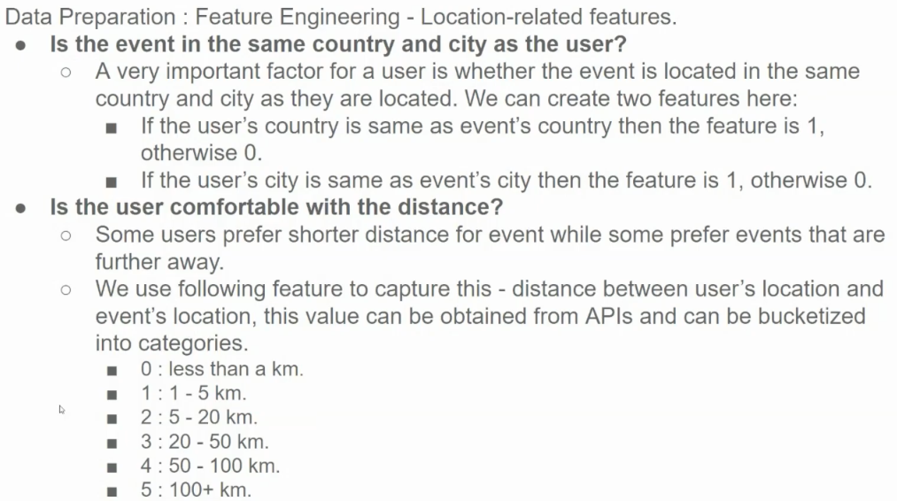

**Why These Features Matter:**

These features are crucial for personalized event recommendations:

* **Relevance:** Users are more likely to be interested in events that are geographically relevant to them.
* **User Preferences:** By considering distance preferences, the system can tailor recommendations to individual users.
* **Feasibility:** These features can help filter out events that are impractical for the user to attend based on distance and location.

By incorporating these features into a recommendation model, we can improve the accuracy and relevance of the recommendations, leading to a better user experience.

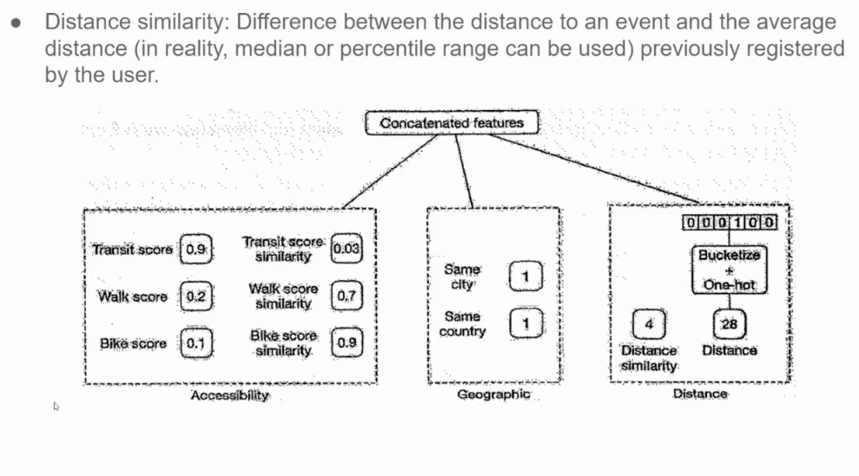

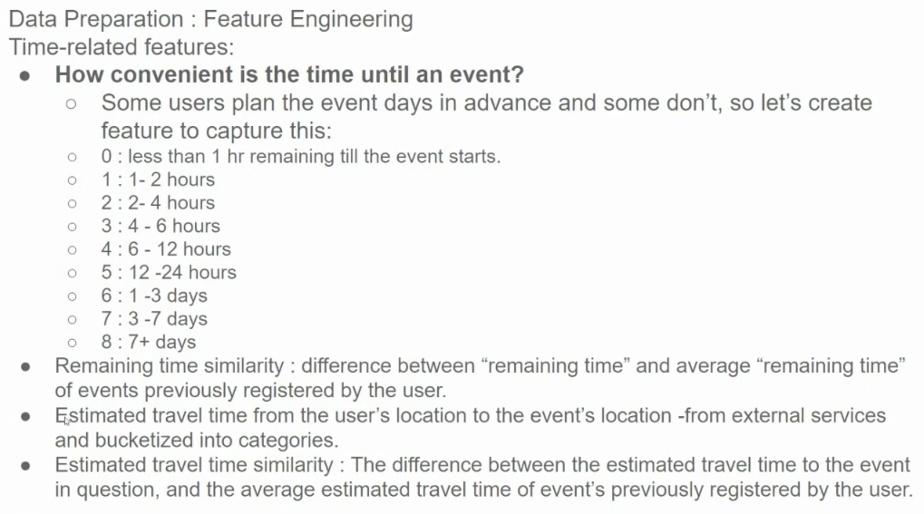

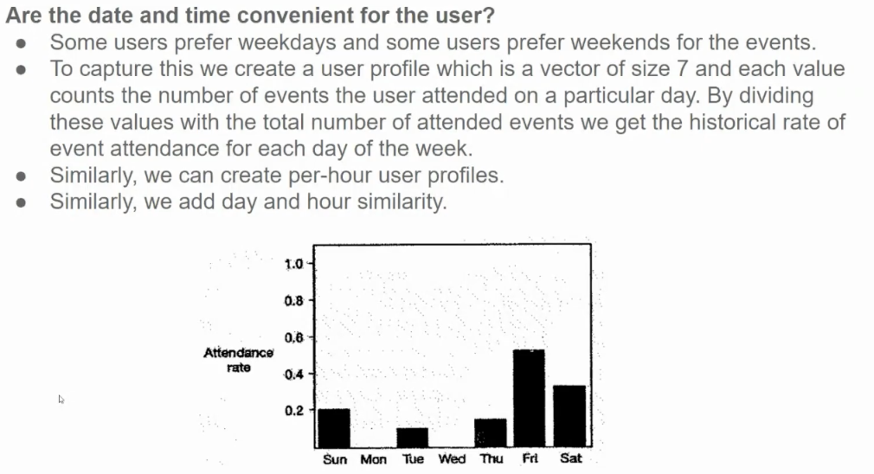

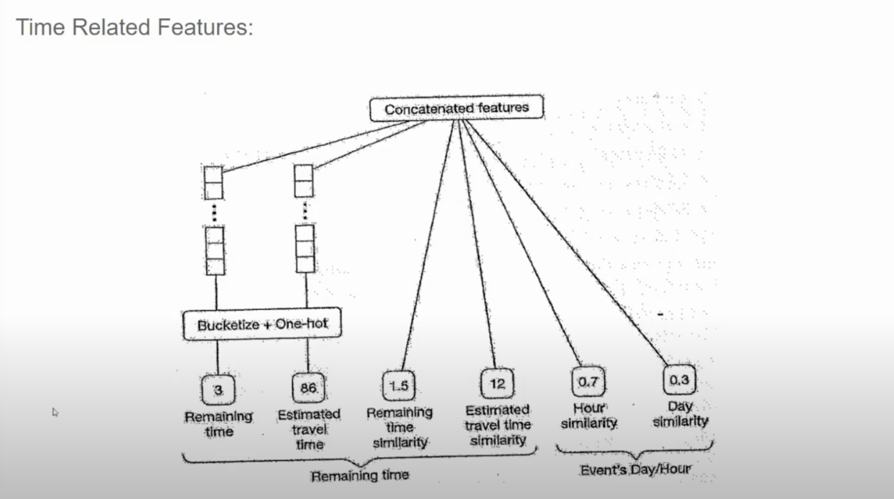

**Key Features and Their Engineering:**

1. **Remaining Time:**
   * **Bucketization:** The remaining time to the event can be categorized into buckets like "less than a day," "1-3 days," "3-7 days," and "more than 7 days."
   * **One-hot Encoding:** Each bucket can be represented as a binary feature.
2. **Estimated Travel Time:**
   * Similar to remaining time, estimated travel time can be bucketed into categories like "less than an hour," "1-2 hours," "2-4 hours," and so on.
   * **One-hot Encoding:** Each bucket can be represented as a binary feature.
3. **Time Similarity:**
   * This feature captures the similarity between the user's preferred event times and the event's scheduled time.
   * It can be calculated using techniques like cosine similarity or Euclidean distance between time vectors.
4. **Event's Day/Hour:**
   * This feature captures the specific day and hour of the event.
   * It can be represented as categorical features or numerical features (e.g., hour of the day).

**Concatenated Features:**

These features can be combined or concatenated to create more complex features. For example, combining "remaining time" and "estimated travel time" can create a feature that captures the overall urgency of the event.

**Why These Features Matter:**

* **Timeliness:** Users are more likely to be interested in events that are happening soon or within their preferred time frame.
* **Convenience:** Users may prefer events that are easier to attend, considering factors like travel time and event duration.
* **Personalization:** By understanding a user's time preferences, the system can tailor recommendations to their specific needs.

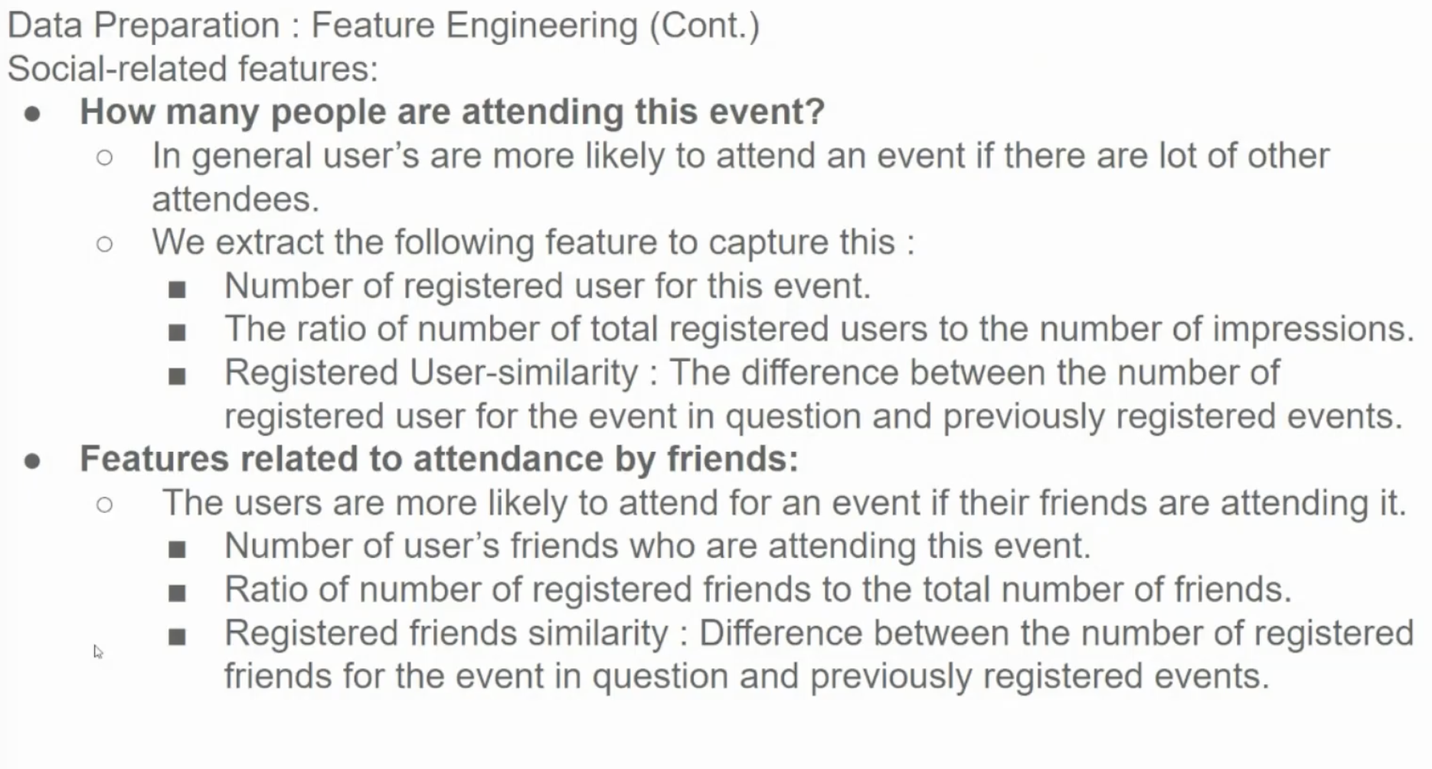

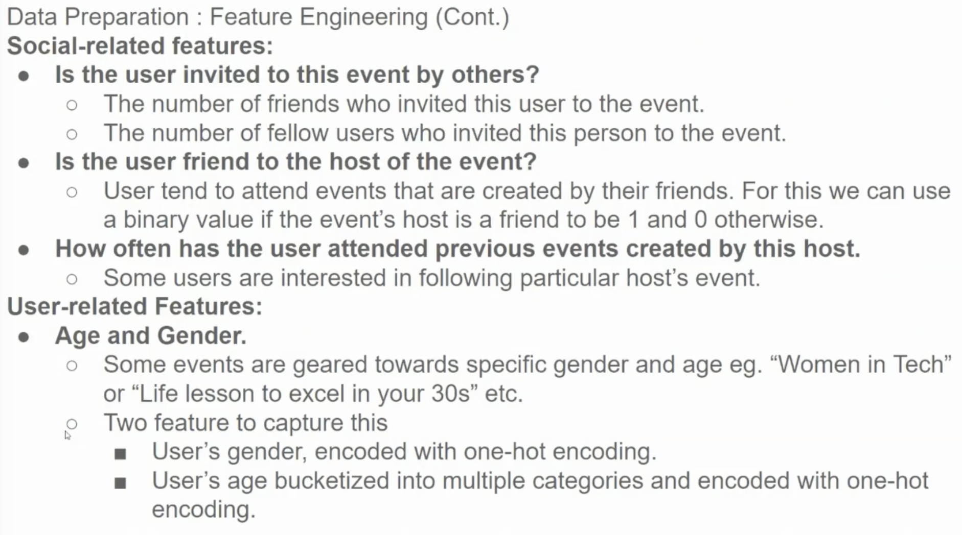

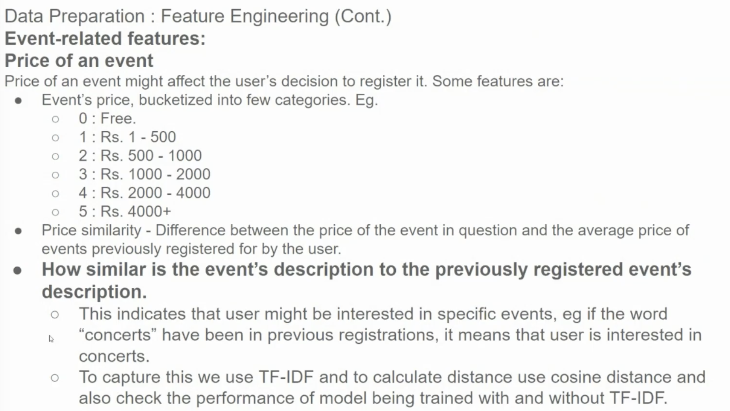

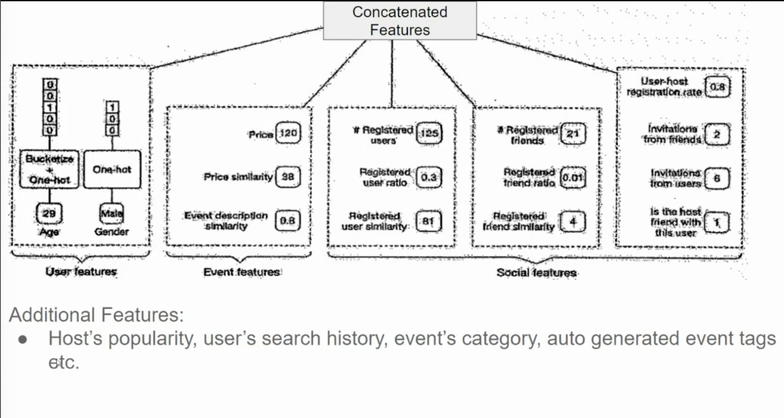

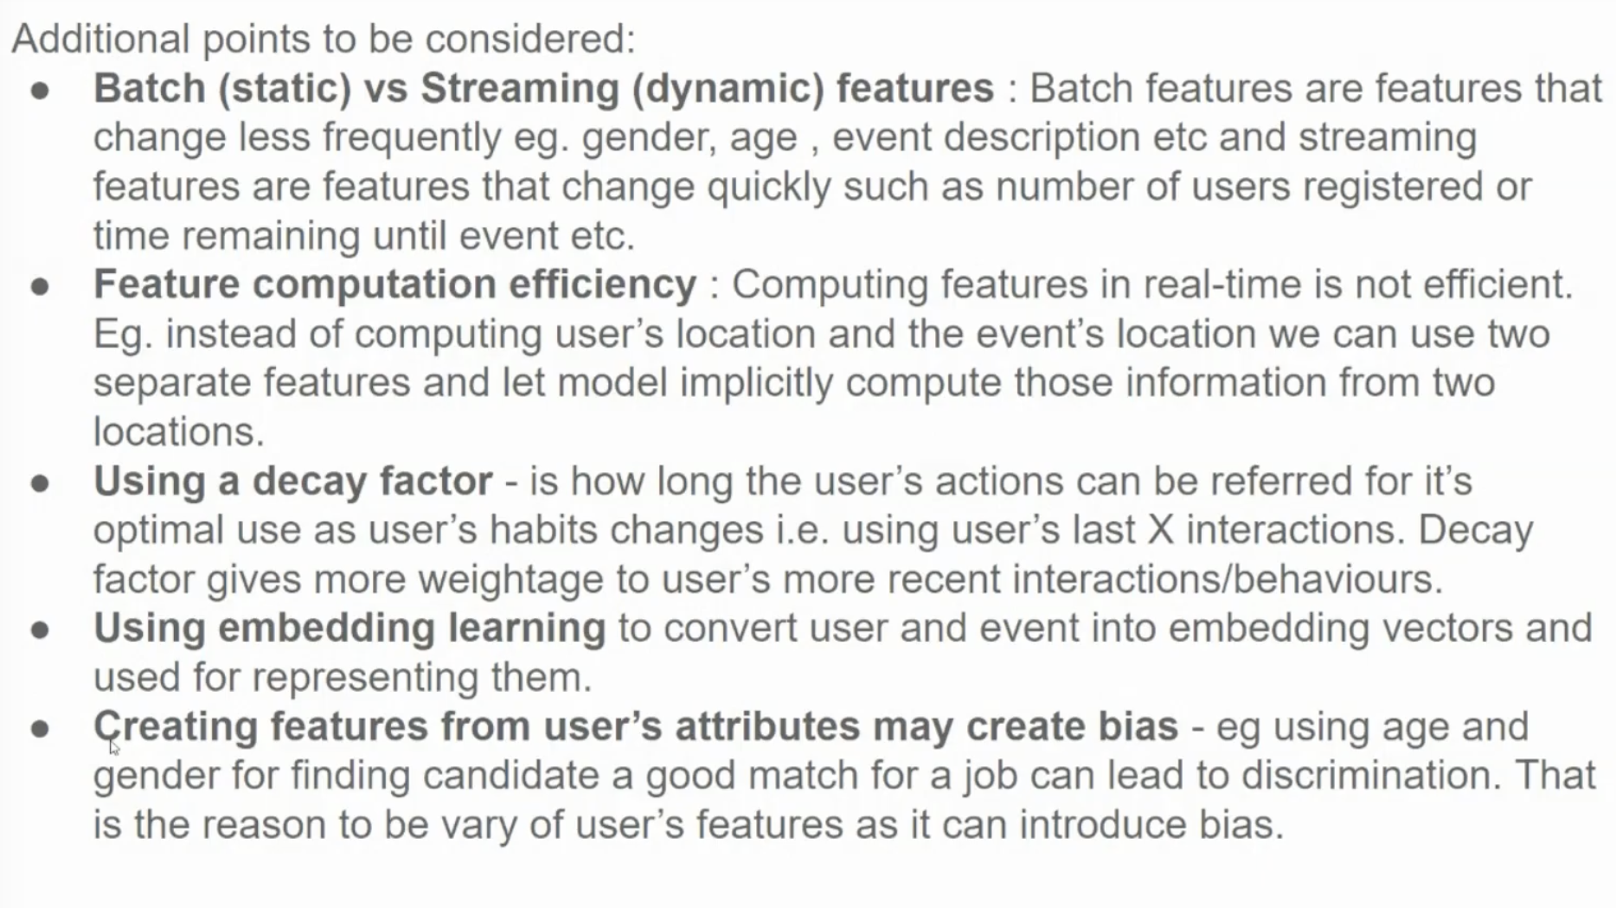

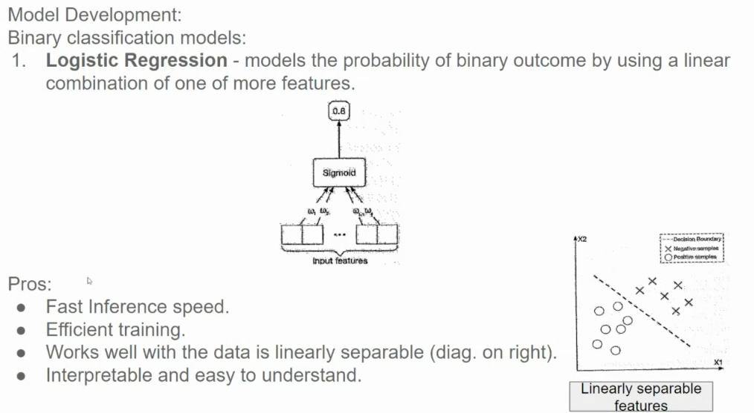

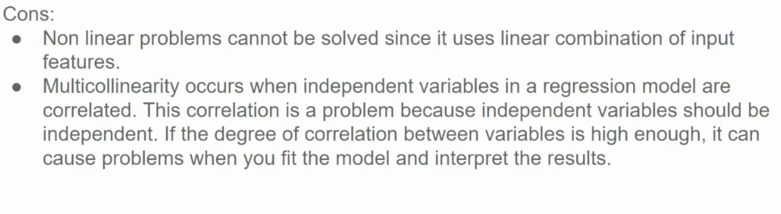

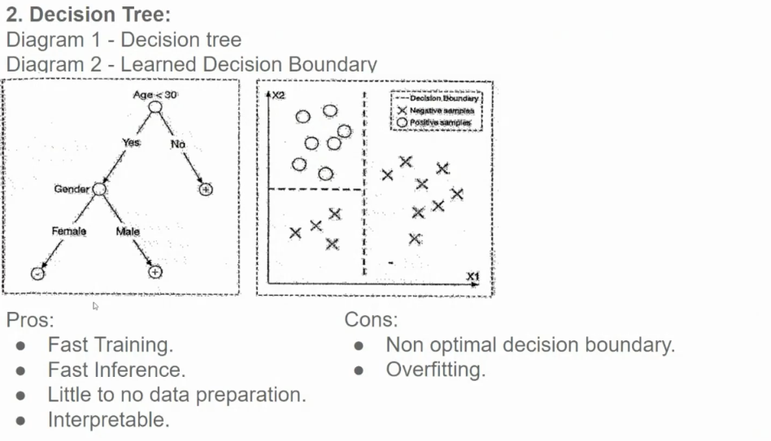

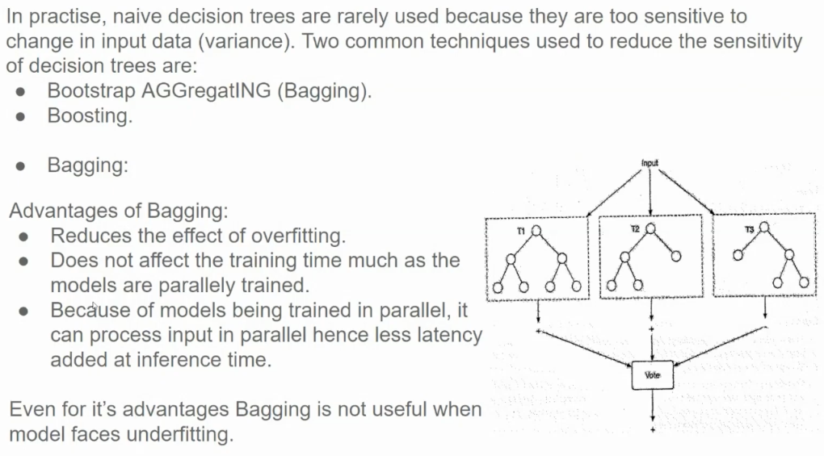

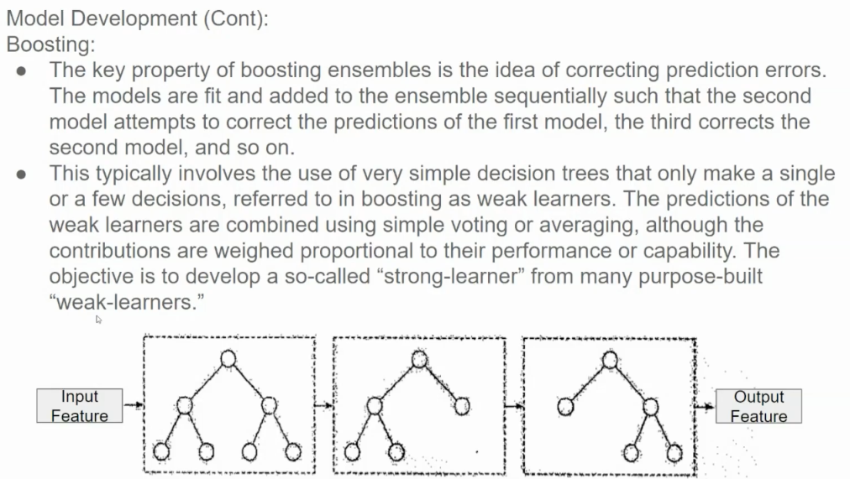

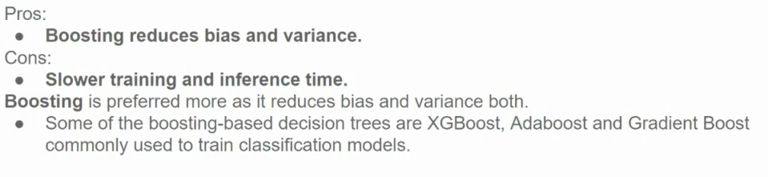

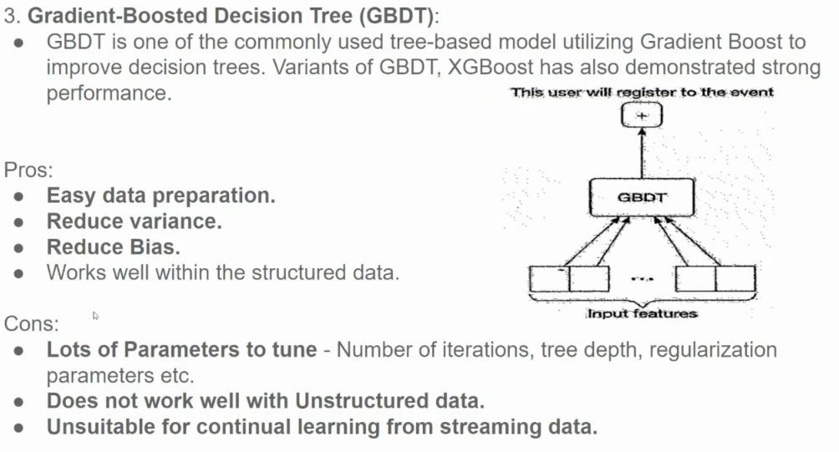

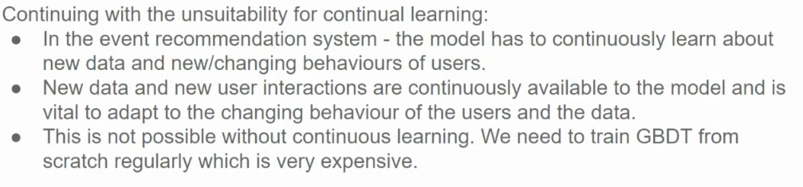

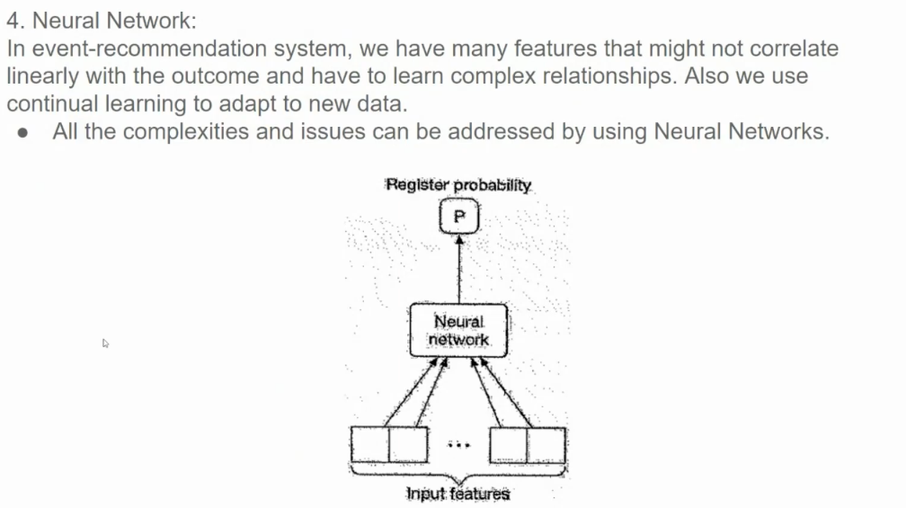

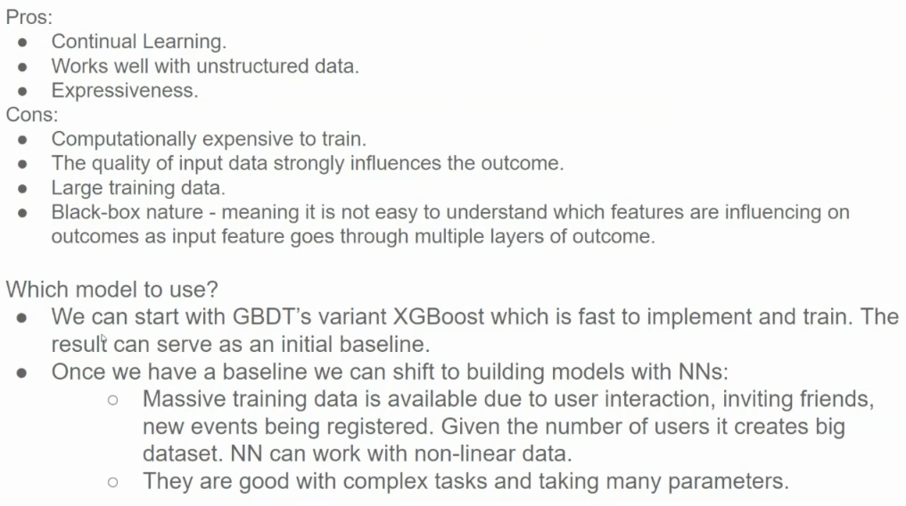

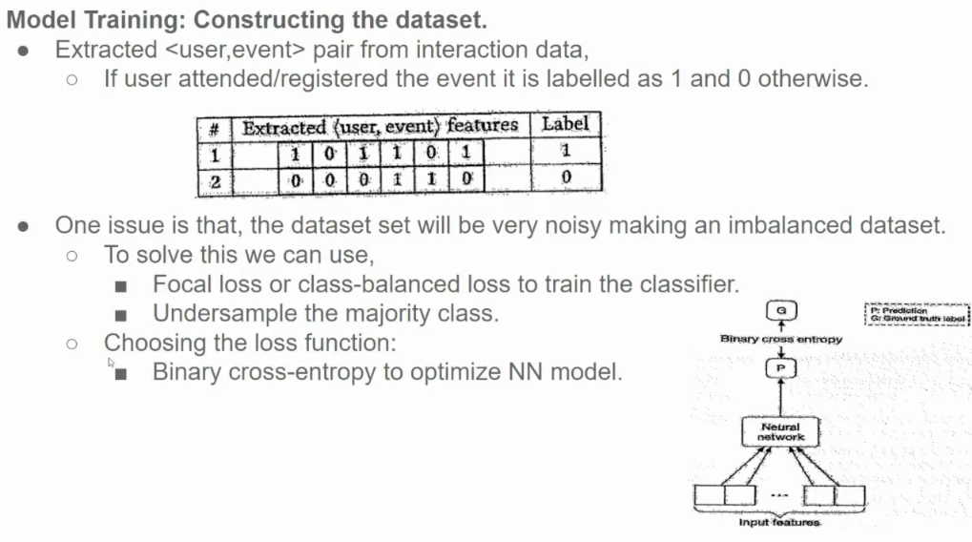

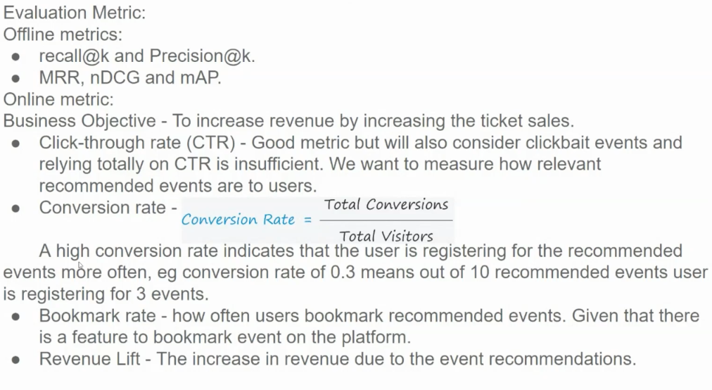

**Offline Metrics**

These metrics are used to evaluate the model's performance on a static dataset.

* **Recall@k and Precision@k:**
  + **Recall@k:** Measures the proportion of relevant items that are recommended within the top k recommendations.
  + **Precision@k:** Measures the proportion of recommended items that are actually relevant within the top k recommendations.
  + These metrics help assess the system's ability to retrieve relevant items and avoid recommending irrelevant ones.
* **MRR (Mean Reciprocal Rank):**
  + Measures the average reciprocal rank of the first relevant item in the ranked list.
  + A higher MRR indicates better performance, as it rewards models that rank relevant items higher.
* **nDCG (Normalized Discounted Cumulative Gain):**
  + Considers the position of relevant items in the ranked list.
  + It assigns higher weights to items ranked higher and penalizes irrelevant items.
  + A higher nDCG indicates better ranking quality.
* **MAP (Mean Average Precision):**
  + Measures the average precision at different recall levels.
  + It considers both precision and recall, making it a comprehensive metric.

**Online Metrics**

These metrics are used to evaluate the model's performance in a real-world setting.

* **Click-Through Rate (CTR):**
  + Measures the proportion of users who click on a recommended event.
  + While CTR is a useful metric, it's important to consider the quality of the clicks. A high CTR could be due to clickbait events rather than truly relevant recommendations.
* **Conversion Rate:**
  + Measures the proportion of users who convert after clicking on a recommended event (e.g., purchasing a ticket).
  + A higher conversion rate indicates that the system is effectively recommending events that users are interested in.
* **Bookmark Rate:**
  + Measures the proportion of users who bookmark recommended events.
  + This metric can be used to assess the long-term impact of recommendations, as bookmarked events may be considered for future purchases.
* **Revenue Lift:**
  + Measures the increase in revenue generated by the recommendation system compared to a baseline (e.g., no recommendations).
  + This is the ultimate metric for evaluating the business impact of the system.

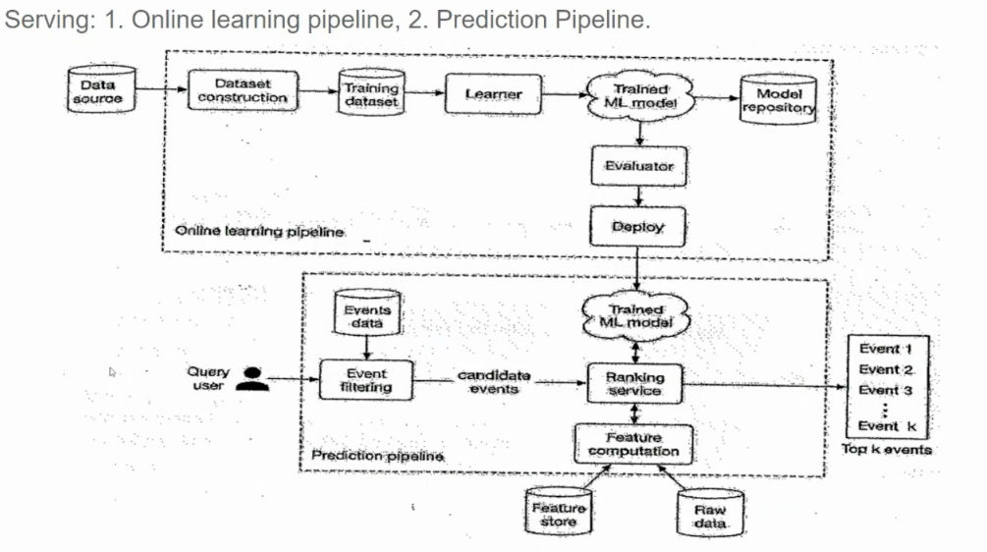

1. **Online Learning Pipeline:** Responsible for continuously training and updating the recommendation model.
2. **Prediction Pipeline:** Responsible for generating recommendations for users.

**Online Learning Pipeline:**

1. **Data Source:** New events and user interactions are continuously fed into the system.
2. **Dataset Construction:** Relevant features are extracted from the raw data to create a structured dataset for training.
3. **Training Dataset:** The constructed dataset is used to train the machine learning model.
4. **Learner:** The machine learning model (e.g., a neural network, decision tree, or ensemble model) is trained on the dataset.
5. **Trained ML Model:** The trained model is stored in a model repository.
6. **Evaluator:** The model's performance is evaluated on a validation dataset to assess its accuracy and effectiveness.
7. **Deploy:** The trained model is deployed to the prediction pipeline.

**Prediction Pipeline:**

1. **Query:** A user submits a query (e.g., search term, location, interests).
2. **Event Filtering:** The system filters events based on the user's query and preferences.
3. **Candidate Events:** A set of candidate events is generated based on the filtering criteria.
4. **Feature Computation:** Features are extracted from the candidate events and user profile to create feature vectors.
5. **Ranking Service:** The trained machine learning model ranks the candidate events based on their feature vectors and the user's query.
6. **Top k Events:** The top k events are selected from the ranked list and presented to the user as recommendations.

**Key Components and Their Roles:**

* **Data Source:** Provides a continuous stream of data to train and update the model.
* **Feature Engineering:** Extracts relevant features from raw data to improve model performance.
* **Machine Learning Model:** Learns patterns from the data to make accurate predictions.
* **Model Deployment:** Deploys the trained model to a production environment.
* **Event Filtering:** Reduces the search space by filtering out irrelevant events.
* **Feature Computation:** Prepares the data for the ranking model.
* **Ranking Service:** Ranks events based on their relevance to the user's query and preferences.

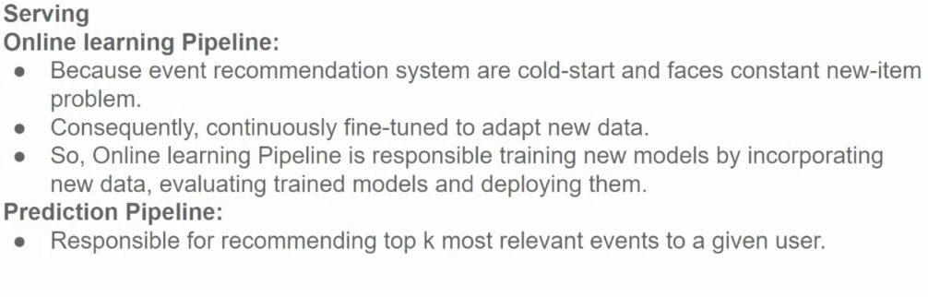

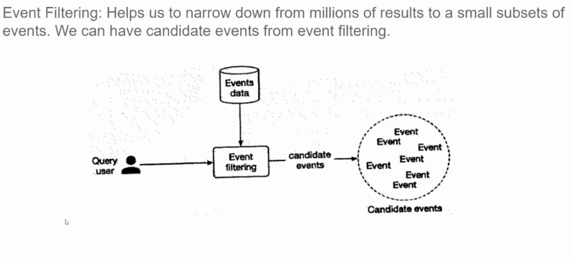

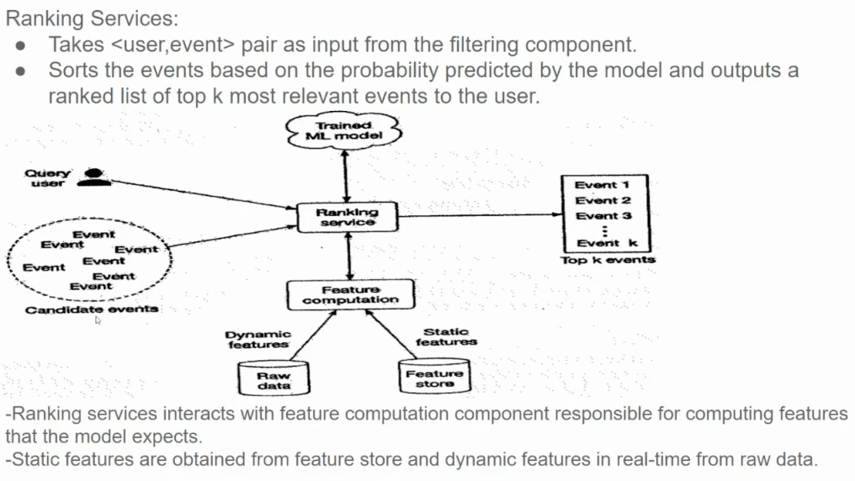

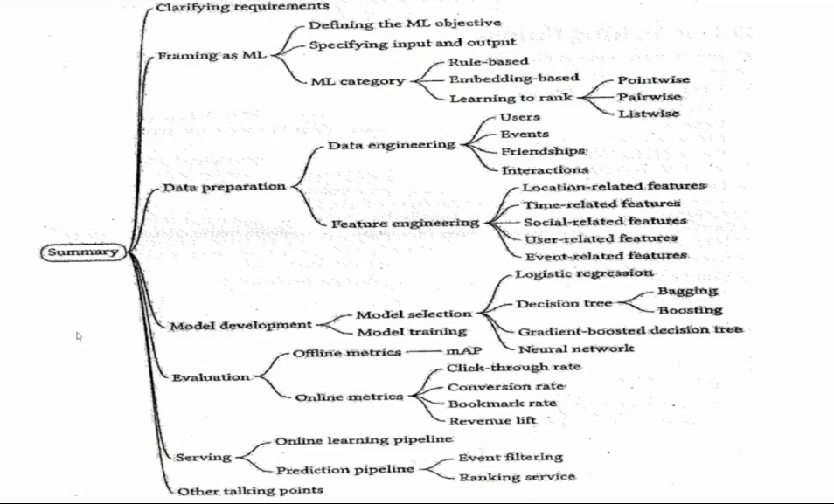

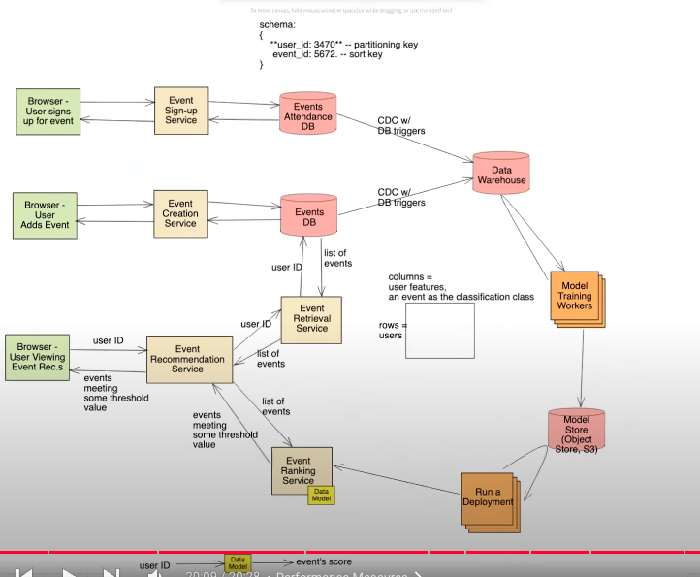

https://www.youtube.com/watch?v=1yLz6uvUJCQ&list=PLlvnxKilk3aKx0oFua-HTtFf-d_inQ8Qn&index=6